Composite Surface Area

Definition
# Source: AI Source: Provided by: [Data Path: Persons Table -> ID Column: 1, Name_En Column: Motasem Essam] -> From: [ChatGPT] on [7/25/2026]
Composite Surface Area is the total area of the exposed outer surfaces of a three-dimensional solid formed by combining two or more geometric solids or by removing portions of a solid.
It is calculated by identifying all external surfaces of the resulting solid and adding their individual areas while excluding surfaces that become internal through joining or overlap.
Composite solids may be formed through:
- Combining two or more solids.
- Attaching one solid to another.
- Placing solids partially inside or on top of other solids.
- Removing one or more smaller solids from a larger solid.
- Creating cavities, holes, or recesses.
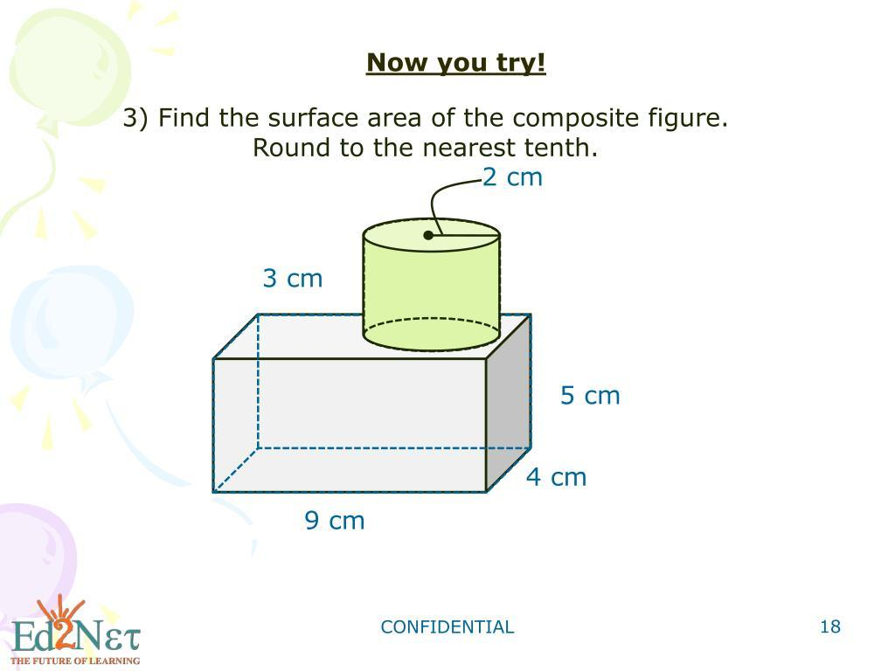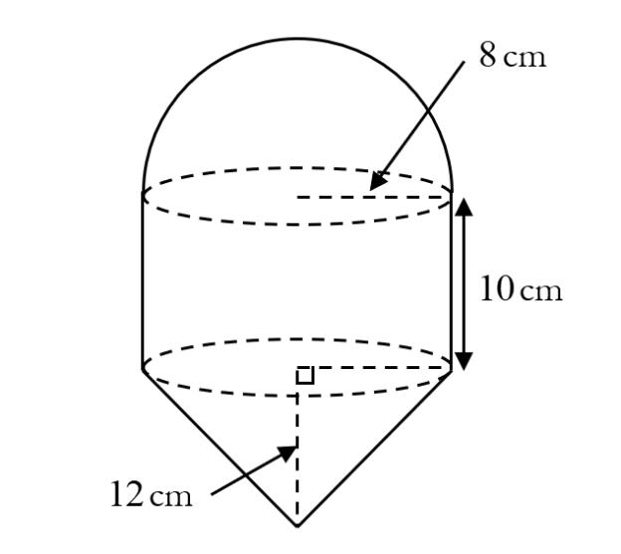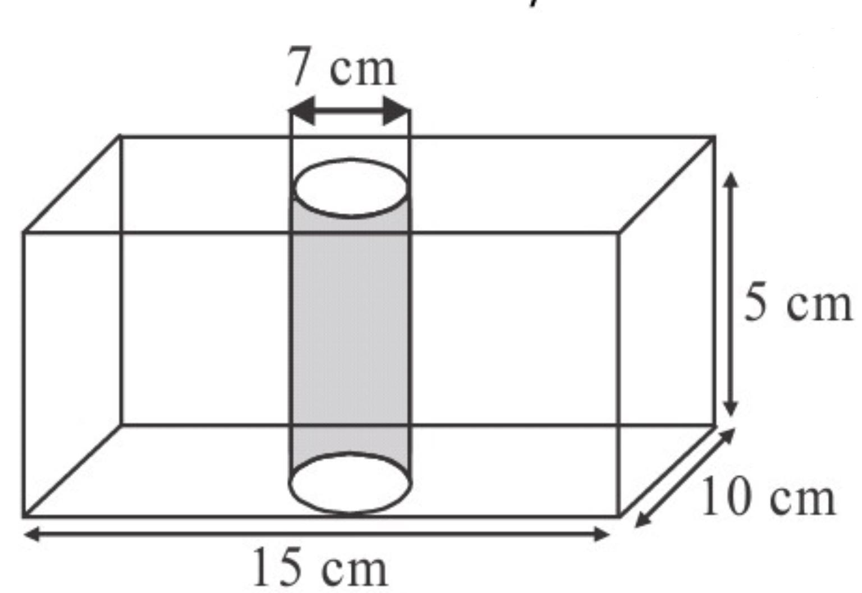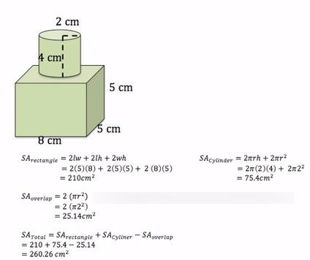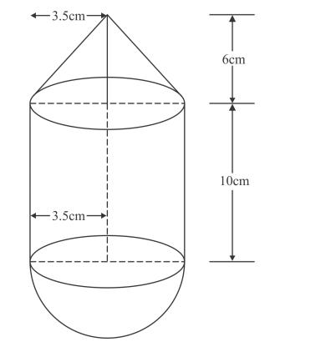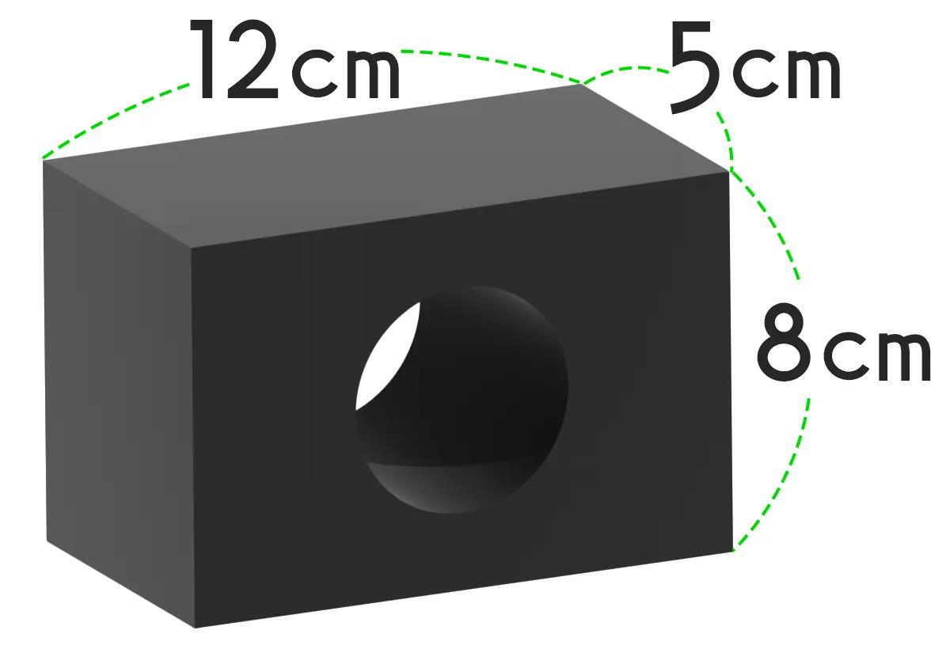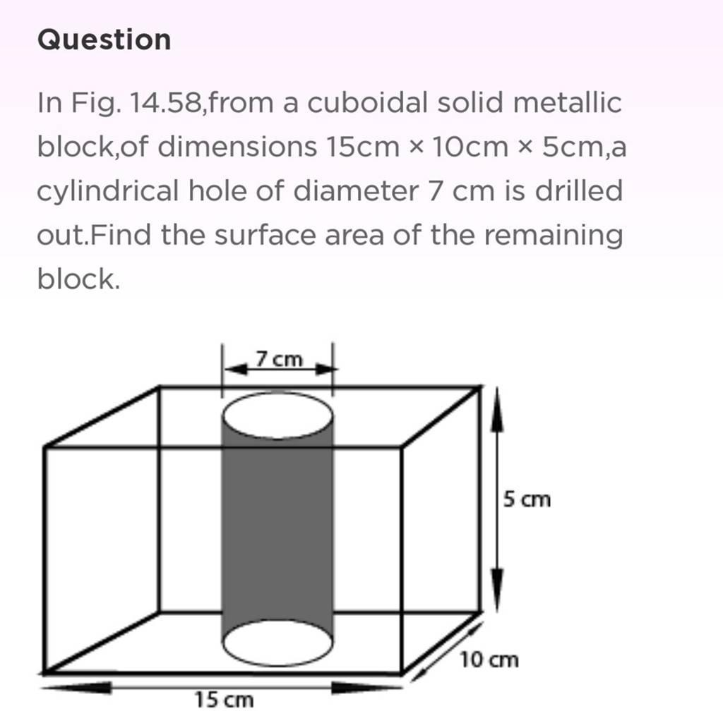

Main Characteristics
# Source: AI Source: Provided by: [Data Path: Persons Table -> ID Column: 1, Name_En Column: Motasem Essam] -> From: [ChatGPT] on [7/25/2026]
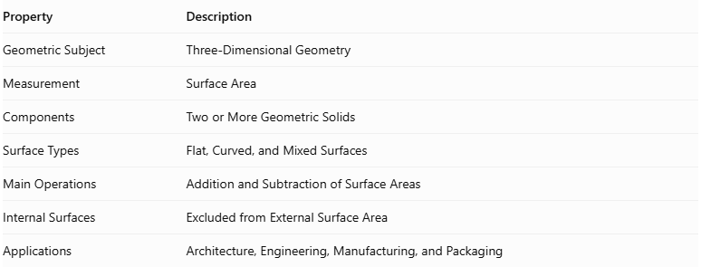
Property | Description
Geometric Subject | Three-Dimensional Geometry
Measurement | Surface Area
Components | Two or More Geometric Solids
Surface Types | Flat, Curved, and Mixed Surfaces
Main Operations | Addition and Subtraction of Surface Areas
Internal Surfaces | Excluded from External Surface Area
Applications | Architecture, Engineering, Manufacturing, and Packaging

Main Types of Composite Surface Area

Additive Composite Surface Area
# Source: AI Source: Provided by: [Data Path: Persons Table -> ID Column: 1, Name_En Column: Motasem Essam] -> From: [ChatGPT] on [7/25/2026]
Formed by joining two or more solids together.
Examples:
- Cube joined to a cube.
- Cylinder joined to a hemisphere.
- Cone placed on top of a cylinder.
- Pyramid joined to a prism.
- Multiple prisms arranged into one solid.
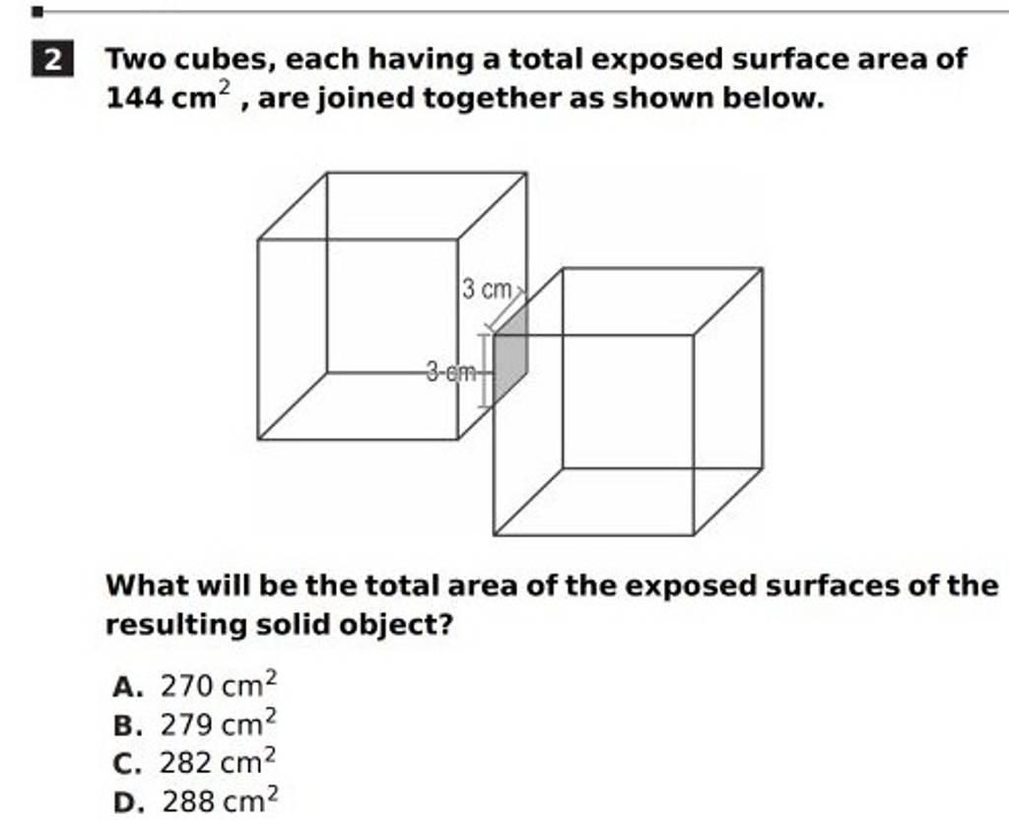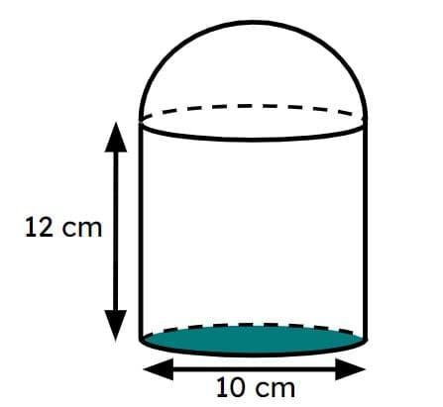

Subtractive Composite Surface Area
# Source: AI Source: Provided by: [Data Path: Persons Table -> ID Column: 1, Name_En Column: Motasem Essam] -> From: [ChatGPT] on [7/25/2026]
Formed by removing a portion of a solid, producing new exposed surfaces.
Examples:
- Cube with a smaller cube removed.
- Cylinder with a cylindrical hole.
- Rectangular prism with a rectangular cavity.
- Sphere with a spherical cavity.
- Solid with a cut-out section.
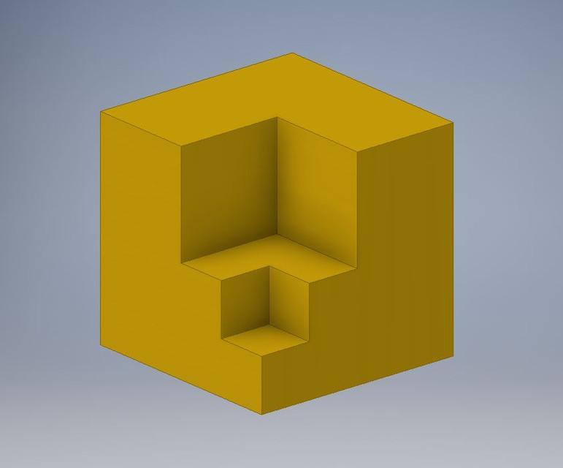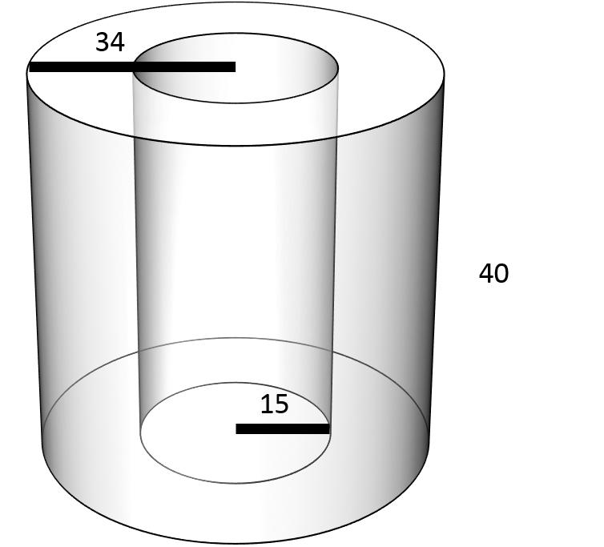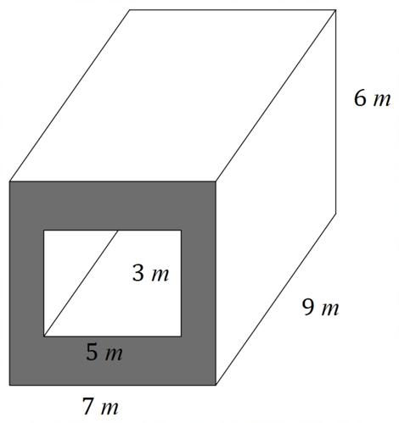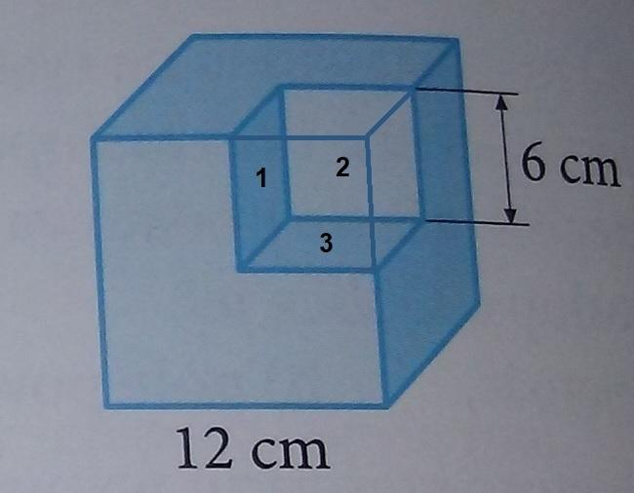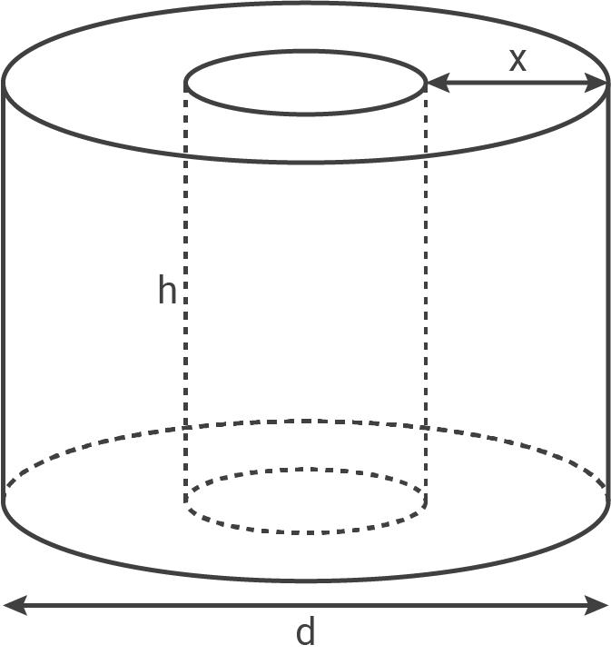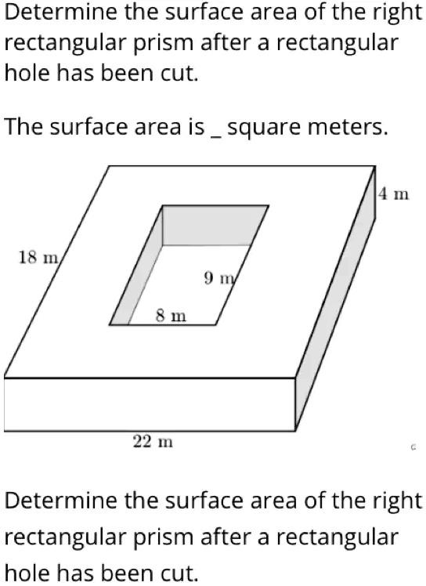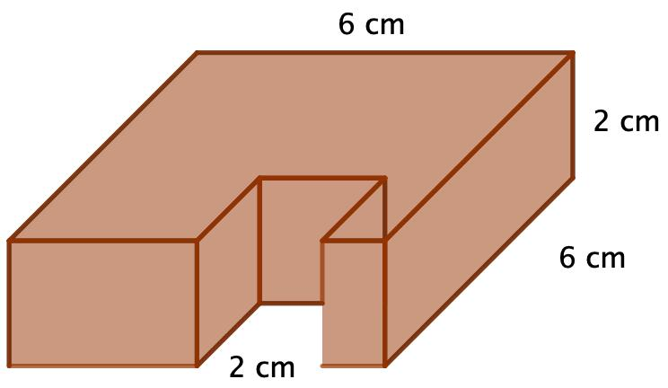

Mixed Composite Surface Area
# Source: AI Source: Provided by: [Data Path: Persons Table -> ID Column: 1, Name_En Column: Motasem Essam] -> From: [ChatGPT] on [7/25/2026]
Formed through a combination of additive and subtractive operations.
Examples:
- A prism with an attached cylinder and a cylindrical hole.
- A rectangular block with an attached hemisphere and a removed section.
- A composite structure containing several solids and internal cavities.
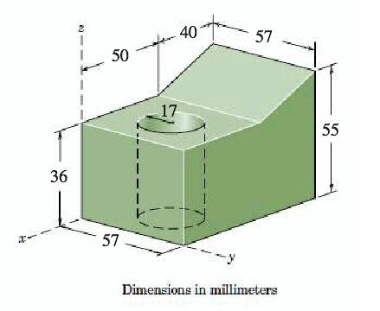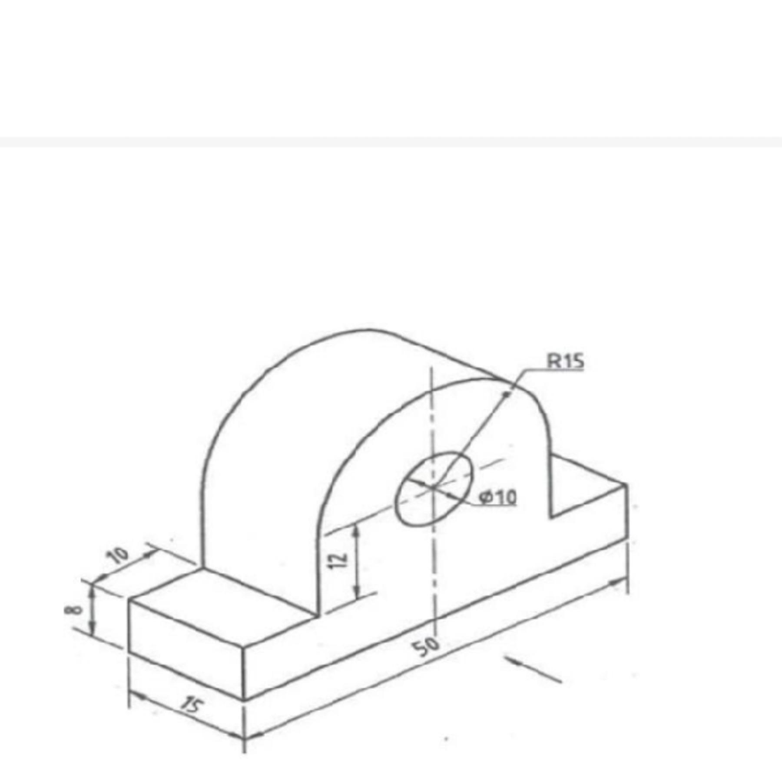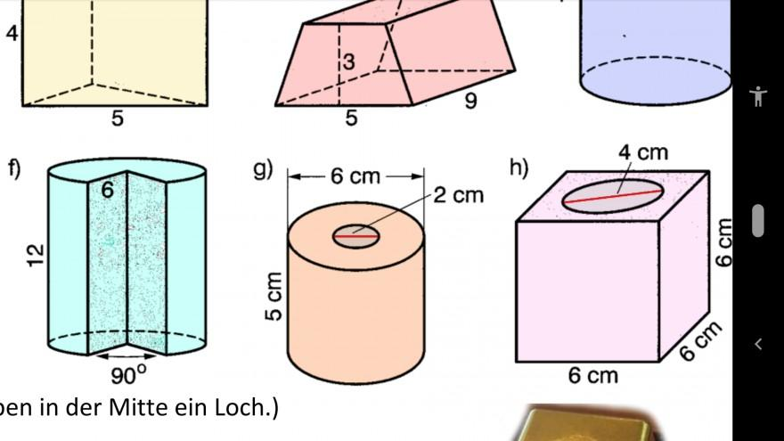

Surface Area Components
# Source: AI Source: Provided by: [Data Path: Persons Table -> ID Column: 1, Name_En Column: Motasem Essam] -> From: [ChatGPT] on [7/25/2026]
Composite solids can contain different types of surfaces.
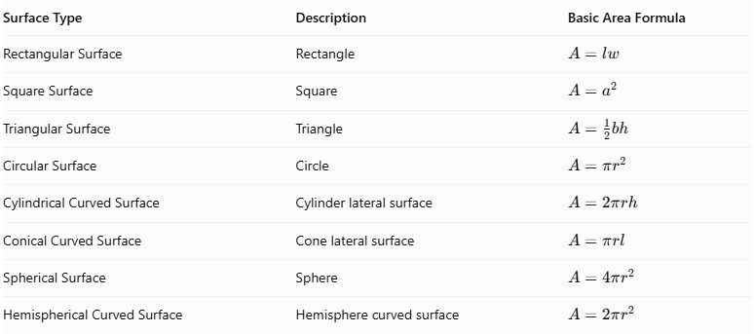
Surface Type | Description | Basic Area Formula
Rectangular Surface | Rectangle | $$A=lw$$
Square Surface | Square | $$A=a^{2}$$
Triangular Surface | Triangle | $$A=\frac{1}{2}bh$$
Circular Surface | Circle | $$A=πr^{2}$$
Cylindrical Curved Surface | Cylinder lateral surface | $$A=2πrh$$
Conical Curved Surface | Cone lateral surface | $$A=πrl$$
Spherical Surface | Sphere | $$A=4πr^{2}$$
Hemispherical Curved Surface | Hemisphere curved surface | $$A=2πr^{2}$$
Where:
- $l$ = Length.
- $w$ = Width.
- $a$ = Side length.
- $b$ = Base length.
- $h$ = Perpendicular height.
- $r$ = Radius.
- $l$ in the cone formula = Slant height.

General Calculation Procedures

Addition Method
# Source: AI Source: Provided by: [Data Path: Persons Table -> ID Column: 1, Name_En Column: Motasem Essam] -> From: [ChatGPT] on [7/25/2026]
When two or more solids are joined, their shared surfaces become internal and must not be counted.
For two solids joined along a common interface:
$$A_{\text{composite}}=A_{1}+A_{2}-2A_{\text{shared}}$$
Where:
- $A_{1}$ = Total surface area of the first solid.
- $A_{2}$ = Total surface area of the second solid.
- $A_{\text{shared}}$ = Area of the joined interface.
For multiple solids:
$$A_{\text{composite}}=\sum_{i=1}^{n}{A_{i}}-2\sum_{j=1}^{m}{A_{\text{shared},j}}$$
This formula assumes that each shared interface is counted twice in the individual surface areas and that there are no additional overlaps or hidden surfaces.

Subtraction Method
# Source: AI Source: Provided by: [Data Path: Persons Table -> ID Column: 1, Name_En Column: Motasem Essam] -> From: [ChatGPT] on [7/25/2026]
When a portion of a solid is removed:
- Identify the removed region.
- Determine which original external surfaces disappear.
- Identify any newly exposed surfaces created by the removal.
- Subtract the removed external surface portions.
- Add the newly exposed surfaces.
The general principle is:
$$A_{\text{new}}=A_{\text{original}}-A_{\text{removed external}}+A_{\text{newly exposed}}$$

Mixed Method
# Source: AI Source: Provided by: [Data Path: Persons Table -> ID Column: 1, Name_En Column: Motasem Essam] -> From: [ChatGPT] on [7/25/2026]
For solids formed through both addition and subtraction:
- Calculate the exposed surfaces of the combined structure.
- Exclude all internal joining surfaces.
- Subtract the external areas removed by cutting.
- Add all newly exposed surfaces.
- Sum the remaining exposed areas.

Worked Examples

Example 1: Two Cubes Joined Face-to-Face
# Source: AI Source: Provided by: [Data Path: Persons Table -> ID Column: 1, Name_En Column: Motasem Essam] -> From: [ChatGPT] on [7/25/2026]
Two identical cubes of side length $a$ are joined along one square face.
Each cube has:
$$A=6a^{2}$$
The shared face area is:
$$A_{\text{shared}}=a^{2}$$
Therefore:
$$A_{\text{composite}}=6a^{2}+6a^{2}-2a^{2}$$
$$\boxed{A_{\text{composite}}=10a^{2}}$$
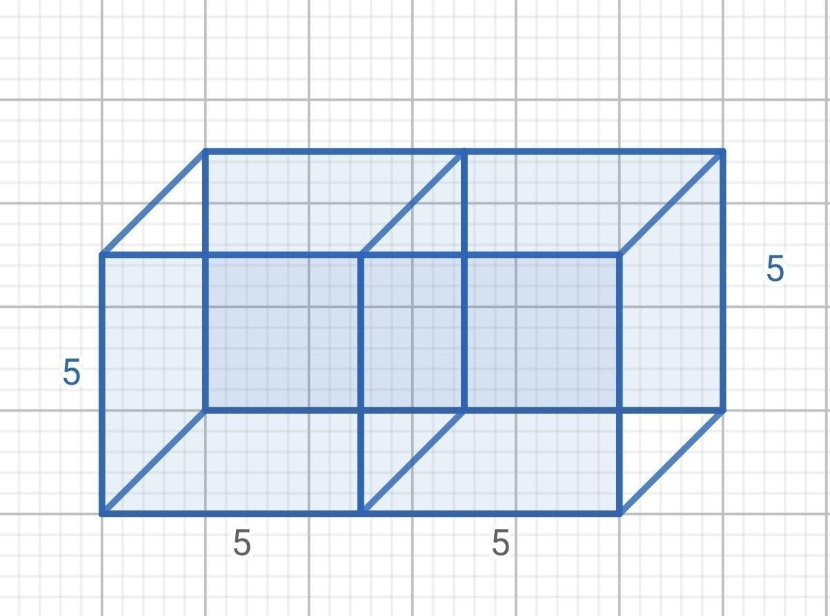

Example 2: Cylinder with a Hemisphere on Top
# Source: AI Source: Provided by: [Data Path: Persons Table -> ID Column: 1, Name_En Column: Motasem Essam] -> From: [ChatGPT] on [7/25/2026]
A hemisphere is attached to the upper circular base of a cylinder. Both have radius $r$, and the cylinder has height $h$.
The exposed surfaces are:
- Cylinder curved surface: $2πrh$.
- Cylinder bottom circular base: $πr^{2}$.
- Hemisphere curved surface: $2πr^{2}$.
The shared circular interface is excluded.
$$A_{\text{composite}}=2πrh+πr^{2}+2πr^{2}$$
$$\boxed{A_{\text{composite}}=2πrh+3πr^{2}}$$
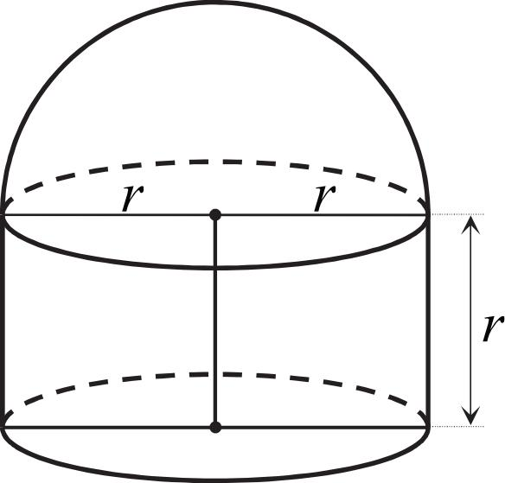

Example 3: Cylinder with a Through-Hole
# Source: AI Source: Provided by: [Data Path: Persons Table -> ID Column: 1, Name_En Column: Motasem Essam] -> From: [ChatGPT] on [7/25/2026]
A cylindrical hole of radius $r$ is drilled through a larger cylinder of radius $R$ and height $h$, parallel to its axis.
Assuming the hole passes completely through the cylinder:
$$A_{\text{composite}}=2πRh+2π(R^{2}-r^{2})+2πrh$$
The terms represent:
- Outer curved surface.
- Two exposed annular end surfaces.
- Inner curved surface of the hole.
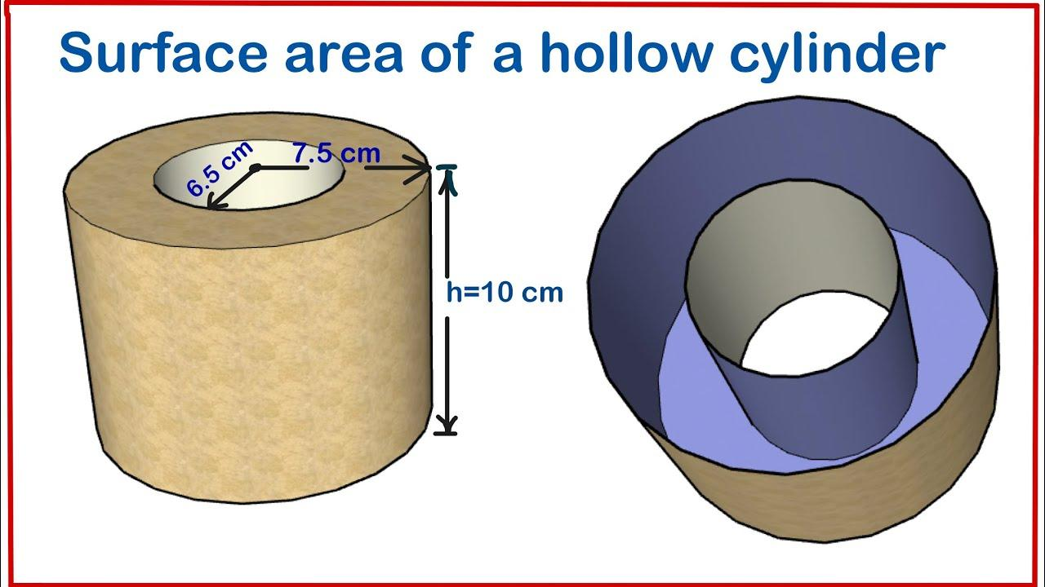

Main Classification
# Source: AI Source: Provided by: [Data Path: Persons Table -> ID Column: 1, Name_En Column: Motasem Essam] -> From: [ChatGPT] on [7/25/2026]
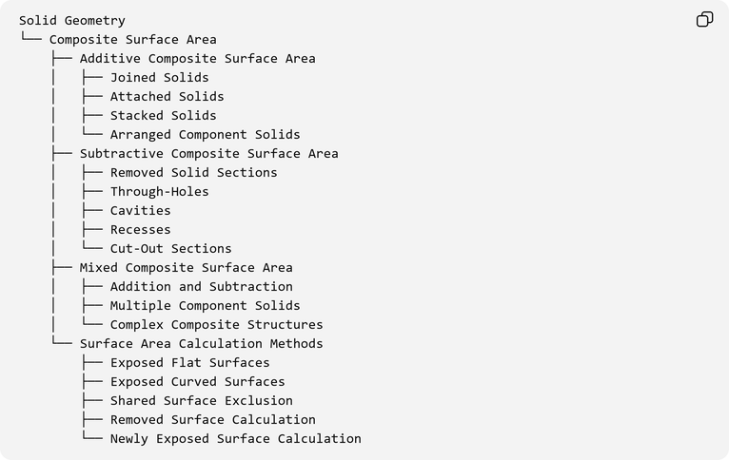
Solid Geometry
└── Composite Surface Area
├── Additive Composite Surface Area
│ ├── Joined Solids
│ ├── Attached Solids
│ ├── Stacked Solids
│ └── Arranged Component Solids
├── Subtractive Composite Surface Area
│ ├── Removed Solid Sections
│ ├── Through-Holes
│ ├── Cavities
│ ├── Recesses
│ └── Cut-Out Sections
├── Mixed Composite Surface Area
│ ├── Addition and Subtraction
│ ├── Multiple Component Solids
│ └── Complex Composite Structures
└── Surface Area Calculation Methods
├── Exposed Flat Surfaces
├── Exposed Curved Surfaces
├── Shared Surface Exclusion
├── Removed Surface Calculation
└── Newly Exposed Surface Calculation

Applications
# Source: AI Source: Provided by: [Data Path: Persons Table -> ID Column: 1, Name_En Column: Motasem Essam] -> From: [ChatGPT] on [7/25/2026]
- Architecture: Calculating exposed surfaces of buildings and structures.
- Engineering: Determining the surface area of assembled mechanical components.
- Manufacturing: Estimating painting, coating, and finishing requirements.
- Packaging: Calculating the external material required for composite packages.
- Construction: Estimating exposed material surfaces in combined structures.
- Industrial Design: Measuring complex products made from multiple geometric components.

Key Points
# Source: AI Source: Provided by: [Data Path: Persons Table -> ID Column: 1, Name_En Column: Motasem Essam] -> From: [ChatGPT] on [7/25/2026]
- Composite surface area measures the total exposed surface of a composite solid.
- It applies to solids formed through addition, subtraction, or both.
- Internal joining surfaces are excluded.
- Newly exposed surfaces created by cutting must be included.
- Both flat and curved surfaces must be considered.
- A correct calculation depends on identifying the actual external boundary of the resulting solid.

Important Distinction
# Source: AI Source: Provided by: [Data Path: Persons Table -> ID Column: 1, Name_En Column: Motasem Essam] -> From: [ChatGPT] on [7/25/2026]
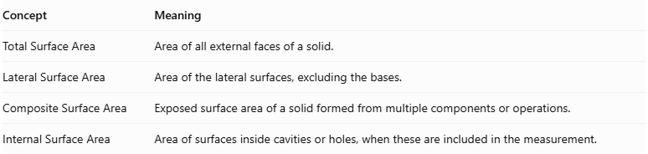
Concept | Meaning
Total Surface Area | Area of all external faces of a solid.
Lateral Surface Area | Area of the lateral surfaces, excluding the bases.
Composite Surface Area | Exposed surface area of a solid formed from multiple components or operations.
Internal Surface Area | Area of surfaces inside cavities or holes, when these are included in the measurement.
Note: Composite surface area does not automatically mean adding the total surface areas of all component solids. Only surfaces belonging to the final solid's boundary are counted.

Conclusion
# Source: AI Source: Provided by: [Data Path: Persons Table -> ID Column: 1, Name_En Column: Motasem Essam] -> From: [ChatGPT] on [7/25/2026]
Composite Surface Area is an important concept in solid geometry for calculating the exposed boundary area of complex three-dimensional structures. It involves combining the surface areas of different geometric components while accounting for shared surfaces, removed sections, cavities, and newly exposed regions.
Understanding additive, subtractive, and mixed composite surface area methods makes it possible to solve problems involving complex solids accurately. These principles are also useful in architecture, engineering, manufacturing, construction, and industrial design, where determining the actual exposed surface area is essential.

